### **1.Go to your aws services select elasticbeanstalk service create a sample application based on your project in mycase I’m using python application so I’m selecting python..**

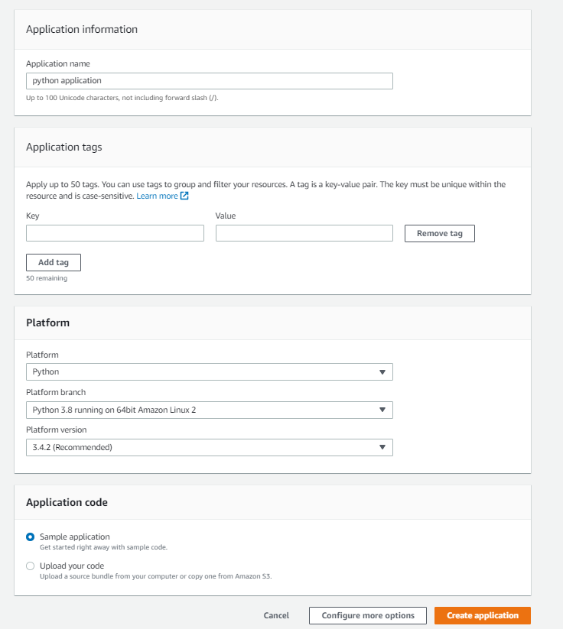

**2.It would take couple minutes to create a application meanwhile go to aws pipeline create a pipeline..**

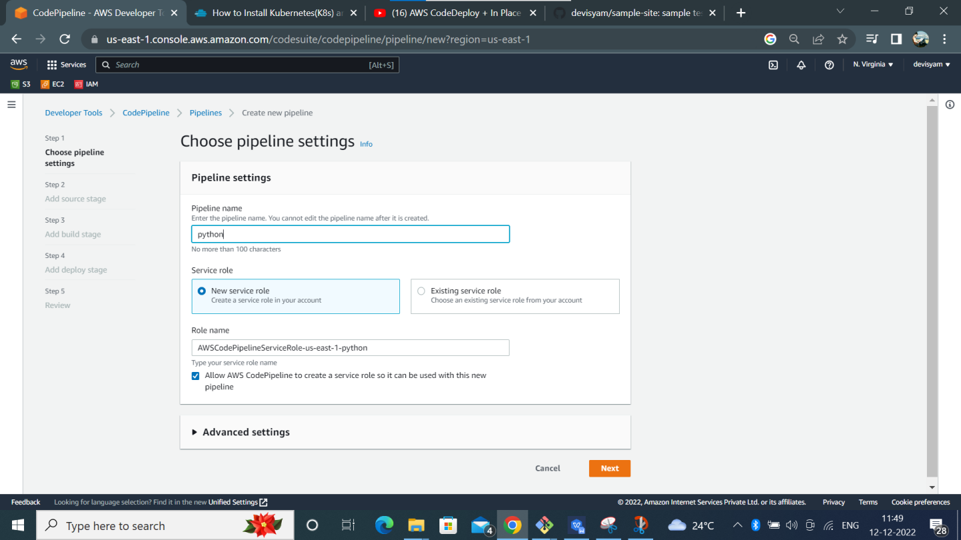

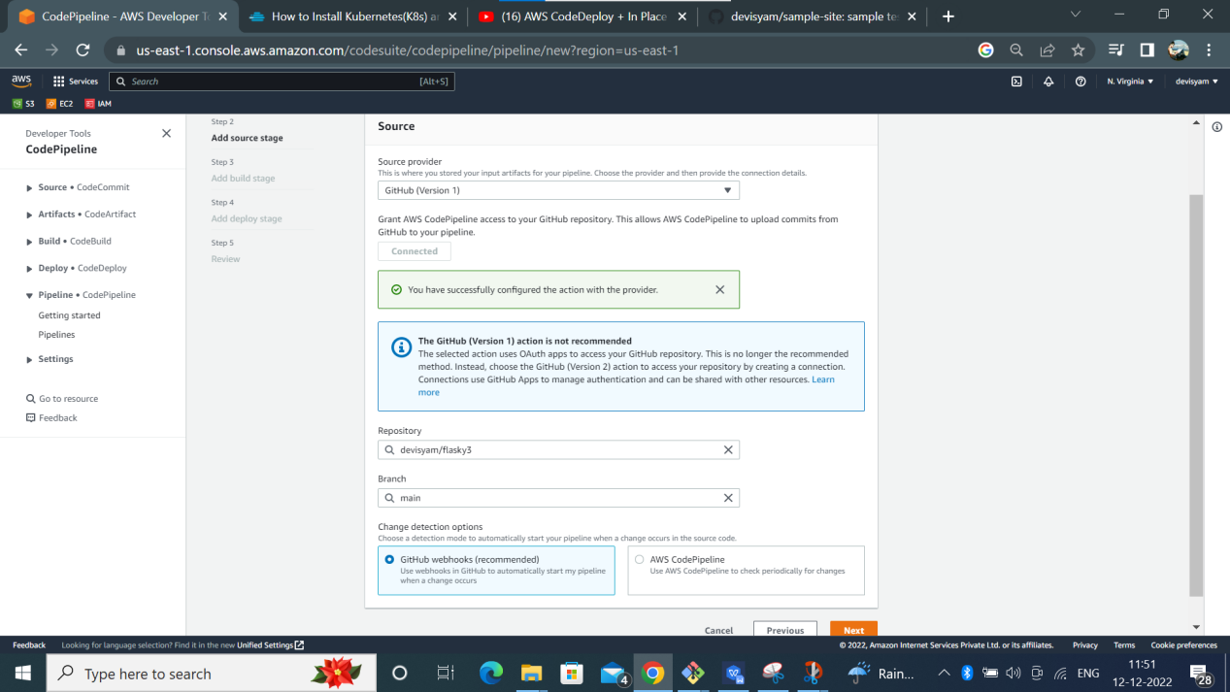

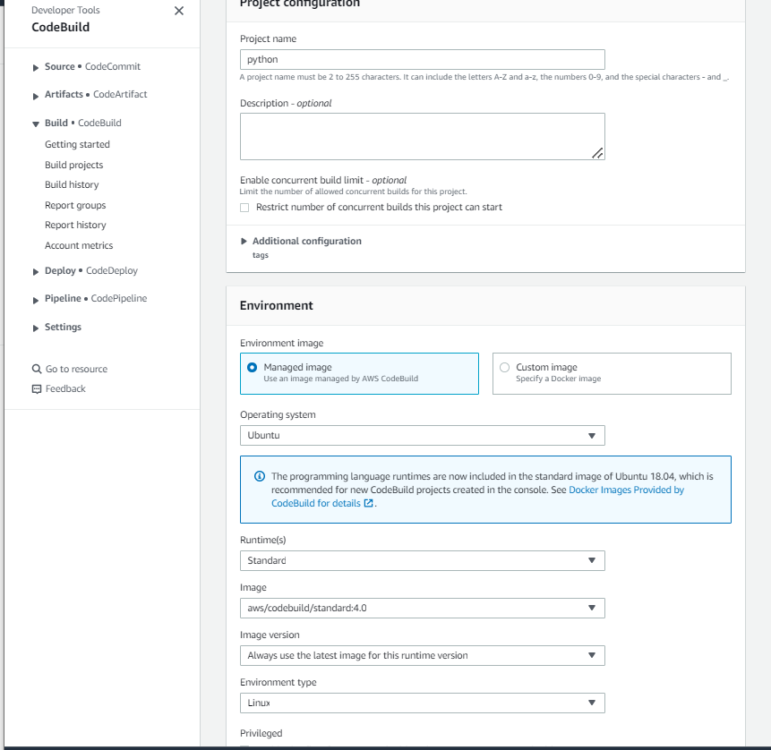

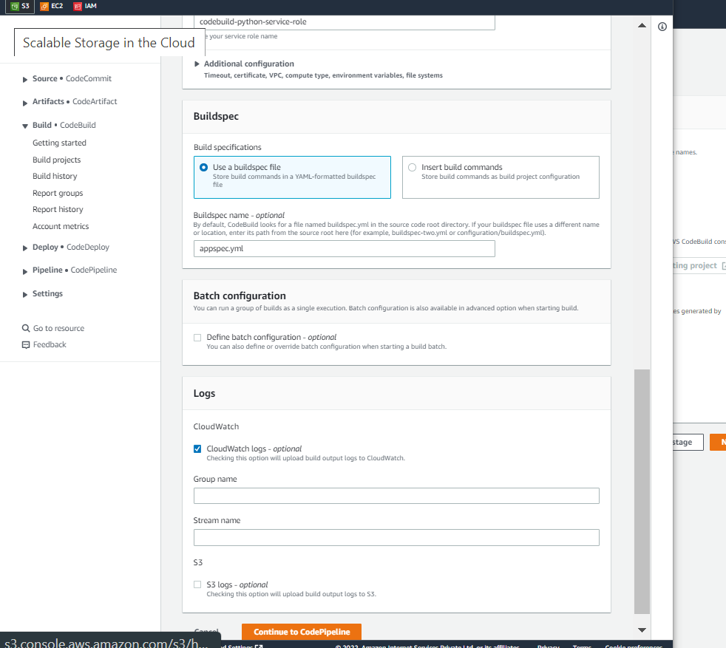

Here you have to specify buildspec.yml also its optional above specified file appspec.yml wrong we have to specify only buildspec.yml and click continue in codepipeline and specify this project in build stage

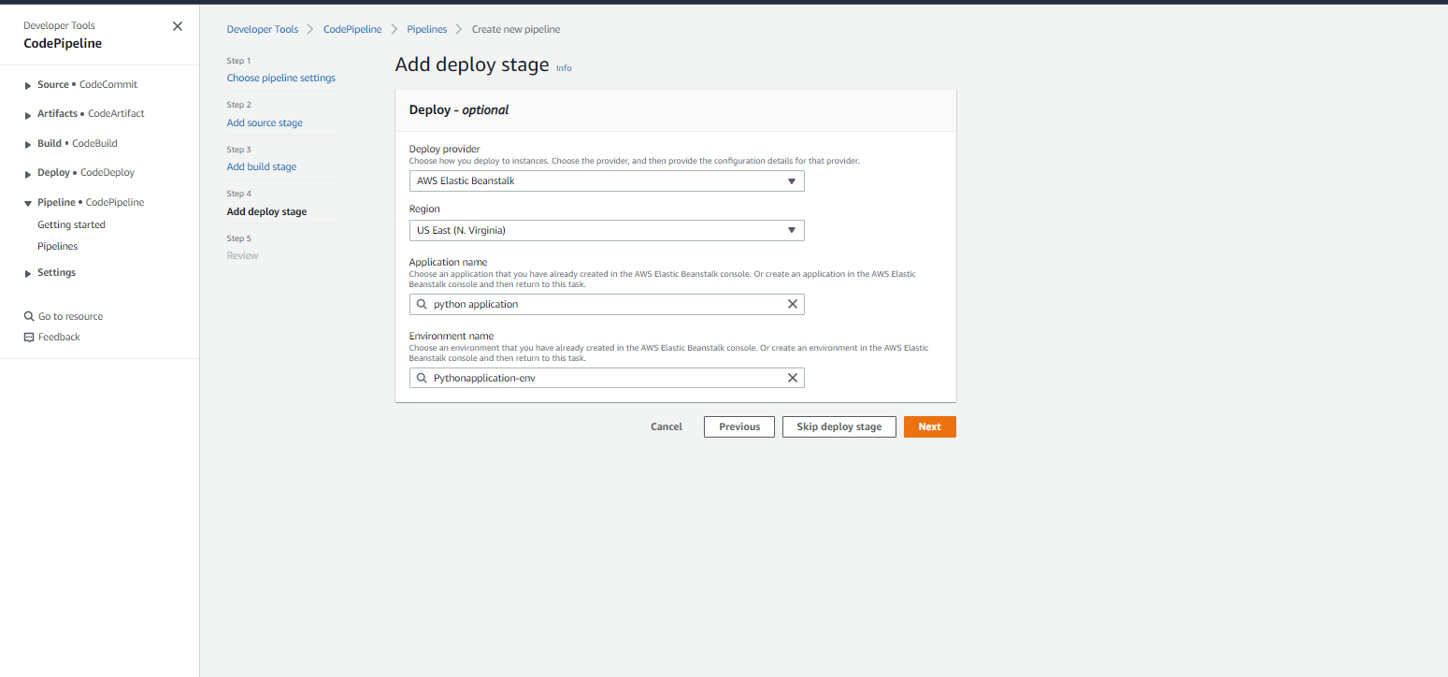

**3.In deploy stage the application name you must choose before what you have created in elasticbeanstalk after that it would take couple of minutes to build&deploy the application..**

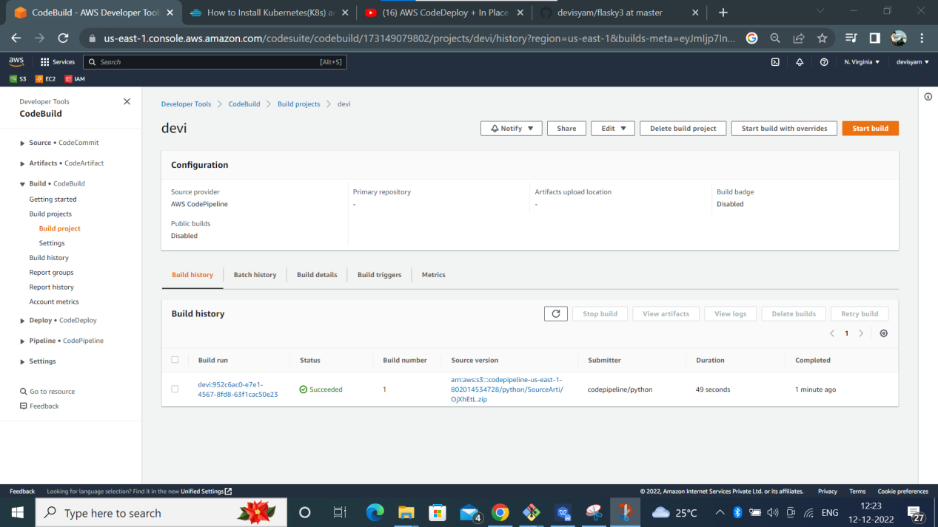

**4.Then you can go to elasticbeanstalk & check the application over there..**

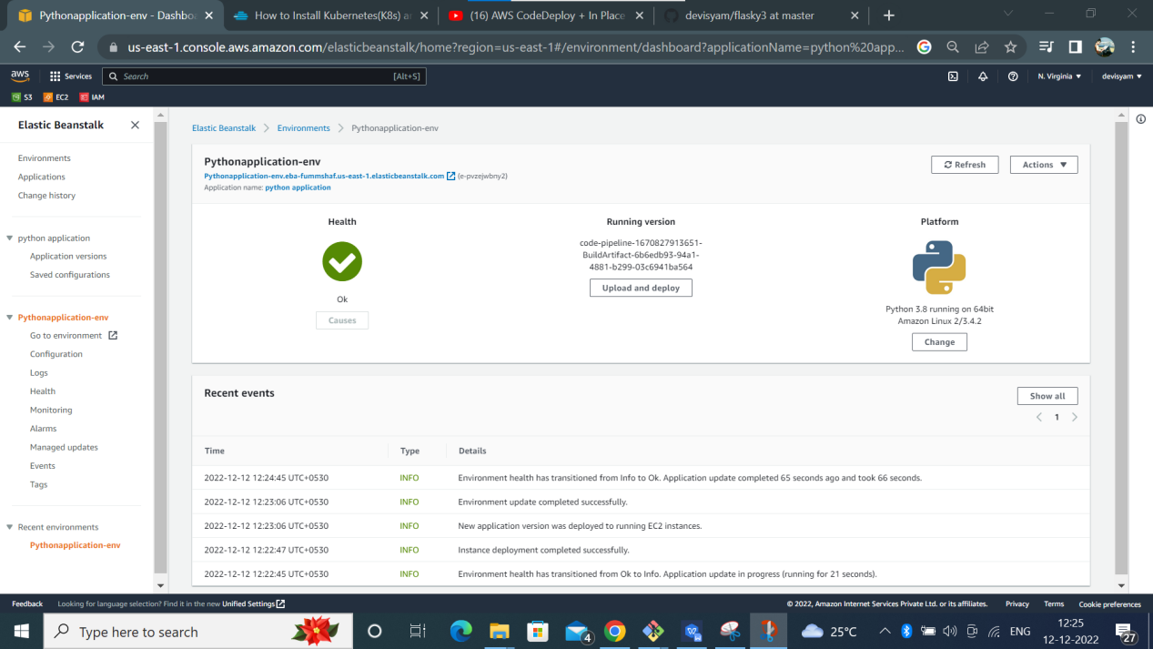

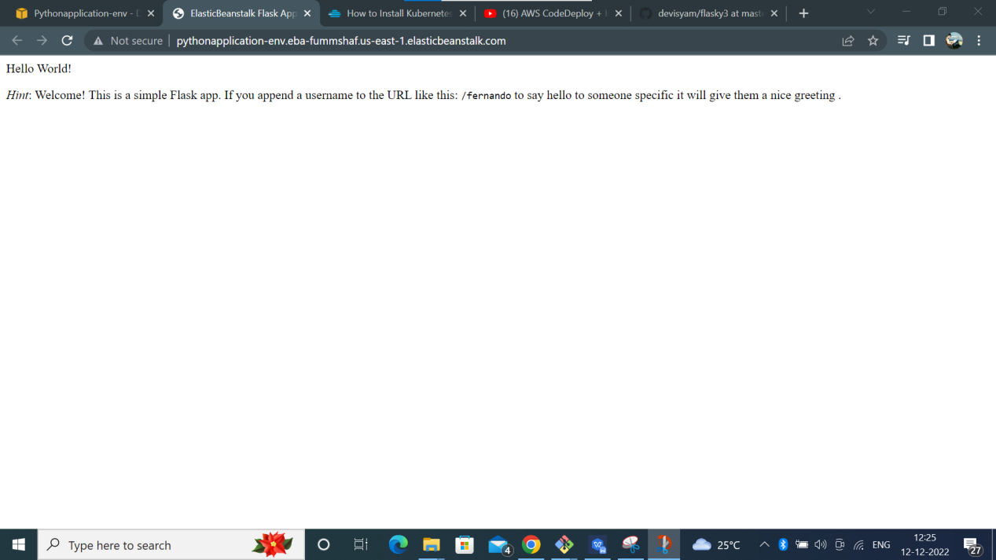

**5.The application seems like this…**